REDOX

PAST EXAM QUESTIONS

Section 1: Principles of oxidation and reduction 2

Section 2: Electrochemical cells 19

WACE 2AB 2013 Q19:
If a substance is oxidised, it means that
- electrons have been transferred to it
- it has lost electrons
- it has produced oxygen in a reaction
- it can now donate oxygen to another substance

WACE 2AB 2012 Q9:
The oxidation number of nitrogen in the series, N₂, N₂O, NO₃⁻, and NH₃ respectively are:
- 0, 0, +5, –3
- 0, –1, –1, +3
- 0, +1, +5, –3
- +2, +2, +1, +1

WACE 2AB 2011 Q10:
Copper(II) oxide undergoes a redox reaction with carbon to produce copper metal and carbon monoxide gas, as shown in the equation below.
CuO(s) + C(s) → Cu(s) + CO(g)
Which one of the following is the reductant in this reaction?
- copper(II) oxide
- carbon
- copper
- carbon monoxide

WACE 2AB 2011 Q11:
Consider the following reaction between manganese and lead ions.
Mn(s) + Pb²⁺(aq) → Mn²⁺(aq) + Pb(s)
Which one of the following statements is correct?
- The manganese metal has removed electrons from the lead ions
- The lead ions have reduced the manganese metal
- Electrons have been transferred from the manganese metal to the lead ions
- The oxidation number of the lead ions has increased

WACE 2AB 2012 Q12:
Which one of the following reactions is not a redox reaction?
- 4 K(s) + O₂(g) → 2 K₂O(s)
- 2 Na(s) + 2 H₂O(ℓ) → 2 NaOH(aq) + H₂(g)
- Li₂O(s) + H₂O(ℓ) → 2 LiOH(aq)
- 2 Na(s) + H₂(ℓ) → 2 NaH(s)

WACE 2AB 2011 Q20:
Which one of the four elements (S, C, Cℓ, Cr) shown in bold below has the lowest oxidation number?
- KHSO₄
- Na₂C₂O₄
- HOCℓ
- K₂Cr₂O₇

WACE 2AB 2010 Q20:
Zn, CO and H₂ are all reducing agents. Which one of the following statements best explains why this is so?
- They can all readily donate electrons
- They are all difficult to oxidise
- None of the them can be reduced
- They all react with oxygen

WACE 2AB 2010 Q21:
Which one of the following represents oxidation?
- Cr₂O₇²⁻ → CrO₄²⁻
- Mn²⁺ → MnO₄⁻
- SO₄²⁻ → SO₂
- NO₂ → NO₂⁻

WACE 2AB 2010 Q22:
In which one of the following compounds is nitrogen in the highest oxidation state?
- N₂
- N₂O₅
- NO
- N₂O₄
WACE 2016 Sample Exam Q12: Originally from WACE 3AB 2011 Q21
How many moles of electrons must be exchanged to oxidise 1 mole of hypophosphorous acid, H₃PO₂, to phosphoric acid, H₃PO₄?
- 2
- 3
- 4
- 5

WACE 2016 Sample Exam Q13: Originally from WACE 3AB 2011 Q22
In which one of the following compounds is rhenium (Re) in the highest oxidation state?
- NaReO₄
- ReCℓO
- Re₂O₃
- ReCℓ₅

WACE 2016 Sample Exam Q14: Originally from WACE 3AB 2010 Q12
In which one of the following will a metal displacement reaction occur?
- A zinc rod is dipped in a 1.0 mol L⁻¹ solution of sodium sulfate
- A copper rod is dipped in a 1.0 mol L⁻¹ solution of cobalt(II) nitrate
- A silver rod is dipped in a 1.0 mol L⁻¹ solution of gold(III) nitrate
- A tin rod is dipped in a 1.0 mol L⁻¹ solution of manganese(II) sulfate

WACE 3AB 2014 Q17:
The equation below shows the reaction when sulfur dioxide gas (SO₂) is bubbled through a solution containing hypochlorite ions (CℓO⁻).
CℓO⁻(aq) + SO₂(g) + H₂O(ℓ) → Cℓ⁻(aq) + SO₄²⁻(aq) + 2 H⁺(aq)
Which of the following statements about this reaction is correct?
- The sulfur in sulfur dioxide is oxidised
- The hydrogen in water is reduced
- The hypochlorite ion is the reducing agent
- The water is the reducing agent

- i only
- ii and iii only
- iii and iv only
- i and iv only
WACE 2AB 2010 Q23:
Methanol, which can be used in fuel cells to provide power for laptops, can be produced by the following redox reaction:
CO(g) + 2 H₂(g) → CH₃OH(ℓ)
Which one of the following statements is true?
- In this reaction hydrogen is the oxidising agent and carbon monoxide is the reducing agent
- The oxidation number of carbon changes from +2 to -2
- The oxygen has been reduced
- The hydrogen has been reduced

WACE 3AB 2015 Q1:
In which of the following compounds is the oxidation number of manganese the lowest?
- Mn₂O₃
- K₂MnO₄
- NaMnO₄
- MnO₂

WACE 3AB 2015 Q5:
Which one of the following reactions can occur spontaneously at 25.0 °C? (Assume the solutions have a concentration of 1.00 mol L⁻¹.)
- C(s) + O₂(g) → CO₂(g)
- 2 Fe²⁺(aq) + Cℓ₂(g) → 2 Fe³⁺(aq) + 2 Cℓ⁻(aq)
- Zn²⁺(aq) + Cu(s) → Zn(s) + Cu²⁺(aq)
- Cu(s) + 2 H⁺(aq) → Cu²⁺(aq) + H₂(g)

WACE 3AB 2013 Q9:
Consider the following reaction.
2 H⁺(aq) + 2 NO₃⁻(aq) + H₂S(g) → 2 NO₂(aq) + S(s) + 2H₂O(ℓ)
Which one of the following statements is true for this reaction?
- The H⁺ is oxidised and the H₂O is reduced
- The oxidation number of the nitrogen changes from +5 to +4 during the reaction
- The sulfur is reduced in the reaction
- This is an acid-base reaction, not a redox reaction

WACE 3AB 2014 Q18:
Consider the following mixtures:
- Solid I₂ added to a solution of H₂S
- Liquid Br₂ is added to a solution of Fe²⁺
- Freshly exposed Aℓ metal is added to a solution of HCℓ
- A piece of cobalt metal is placed in an aqueous solution of Cr³⁺
Based on E° values, in which of the above mixtures will a chemical reaction occur?
- ii only
- i and iii only
- i, ii and iii only
- iii and iv only

WACE 3AB 2012 Q9:
Identify the oxidant in the following reaction:
2 Aℓ(s) + 2 Cr₂O₃(s) → Aℓ₂O₃(s) + 2 Cr(s)
- Aℓ
- Cr₂O₃
- O
- Cr

WACE 3AB 2012 Q11:
Which one of the reactions below is most likely to occur spontaneously?
- H₂(g) + PbSO₄(s) → 2 H⁺(aq) + Pb(s) + SO₄²⁻(aq)
- Zn²⁺(aq) + Fe(aq) → Zn(s) + Fe²⁺(aq)
- Cu²⁺(aq) + Ni(s) → Cu(s) + Ni²⁺(aq)
- 2 Fe³⁺(aq) + H₂O₂(aq) → O₂(g) + 2 Fe²⁺(aq) + 2 H⁺(aq)

WACE 3AB 2011 Q23:
Corrosion is a redox process. Which one of the following explains why coating iron with nickel protects the iron from corrosion?
- Nickel accepts electrons from iron.
- Iron and nickel form an alloy that is particularly resistant to redox processes.
- Nickel is a stronger oxidising agent than iron.
- The thin coating of nickel prevents iron from reacting.
Use the table of standard reduction potentials in the Chemistry Data Sheet to answer WACE 2013 Questions 10 and 11.

WACE 3AB 2013 Q10:
Predict in which of the following a reaction would occur. Assume all solutions are 1.0 mol L⁻¹.
- Acidified potassium permanganate is mixed with potassium iodide solution
- Chlorine gas is bubbled through hydrogen sulfide solution
- Acidified potassium dichromate is mixed with potassium fluoride
- An iron(II) sulfate solution is placed in a nickel container
- A piece of copper metal is placed in a hydrochloric acid solution

- i and ii only
- i, ii and iii only
- ii and v only
- ii, iii and v only

Use the following additional table of standard reduction potentials to answer Question 11.
Half-reaction | E° (V)
2 HCℓO₂ + 6 H⁺ + 6 e⁻ → Cℓ₂(g) + 4 H₂O | 1.64
2 HOCℓ + 2 H⁺ + 2e⁻ → Cℓ₂(g) + 2 H₂O | 1.63
2 CℓO₃⁻ + 12 H⁺ + 10 e⁻ → Cℓ₂(g) + 6 H₂O | 1.47
2 CℓO₄⁻ + 16 H⁺ + 14 e⁻ → Cℓ₂(g) + 8 H₂O | 1.42
CℓO⁻ + H₂O + 2 e⁻ → Cℓ⁻ + 2 OH⁻ | 0.89
CℓO₂⁻ + 2 H₂O + 4 e⁻ → Cℓ⁻ + 4 OH⁻ | 0.78

- CℓO⁻, CℓO₂⁻, CℓO₃⁻ and CℓO₄⁻
- HCℓO₂ and HOCℓ
- HCℓO₂, HOCℓ, CℓO₃⁻ and CℓO₄⁻
- All can react with hydrogen peroxide to produce oxygen gas

WACE 3AB 2010 Q10:
Which one of the four elements (Cℓ, Cr, P, Mn) underlined below has the lowest oxidation state?
- HCℓO₂
- K₂CrO₄
- Na₃PO₄
- KMnO₄
WACE 3AB 2010 Q11:
Which of the following are redox reactions?
- N₂ + 3 H₂ → 2 NH₃
- CaCO₃ + 2 HCℓ → CaCℓ₂ + H₂O + CO₂
- Zn + 2 HCℓ → ZnCℓ₂ + H₂
- S + O₂ → SO₂

- Equations i, ii, iii and iv
- Equations i, iii and iv only
- Equations ii, iii and iv only
- Equations iv only

WACE 3AB 2010 Sample Q14:
Which of the four elements (Fe, S, O or Cr) shown in bold below has the highest oxidation state?
- FeCℓ₃
- Na₂SO₃
- K₂Cr₂O₇
- Cr₂O₃

WACE 3AB 2010 Sample Q16:
Chlorine gas is bubbled through a solution of a salt, and the solution turns brown. A separate solution of the same salt is added to a solution of lead(II) nitrate, and a bright yellow precipitate is formed. Which of the following is the most likely identity of the ion causing the colour changes?
- Iron(III)
- Bromide
- Iodide
- Chromate

TEE 2009 Q20:
In which one of the following reactions is the manganese-containing species acting as a reducing agent?
- MnO + Mg → Mn + MgO
- MnCℓ₂ + 2 H₂O + Cℓ₂ → MnO₂ + 4 Cℓ⁻ + 4H⁺
- MnO₂ + 2 Ag + 4 H⁺ → Mn²⁺ + 2 Ag⁺ + 2 H₂O
- MnO₄⁻ + 5 Fe²⁺ + 8 H⁺ → Mn²⁺ + 5 Fe³⁺ + 4 H₂O

TEE 2007 Q17:
Consider the following equation:
2 BrO₃⁻(aq) + 10 I⁻(aq) + 12 H⁺(aq) → 5 I₂(aq) + Br₂(ℓ) + 6 H₂O(ℓ)
For this reaction, which one of the following is true?
- BrO₃⁻ is the reducing agent
- H⁺ is reduced
- I⁻ is the oxidising agent
- BrO₃⁻ is reduced

TEE 2007 Q18:
Consider the statements about the following reaction:
2 H₂O₂(ℓ) → 2 H₂O(ℓ) + O₂(g)
- H₂O₂ is reduced
- H₂O₂ is oxidised
- H₂O₂ acts as a reducing agent
- This is not a redox reaction
Which of the above statements are true?
- iv only
- ii and iii only
- i only
- i, ii and iii only

TEE 2007 Q19:
Consider the following reaction:
2 VO₂⁺ + H₂O₂ + 2 H⁺ → 2 VO²⁺ + O₂ + 2 H₂O
Which one of the following statements is true for this reaction?
- The VO₂⁺ is reduced and the H⁺ is oxidised
- The H⁺ is reduced and the H₂O₂ is oxidised
- The VO₂⁺ is the oxidising agent and the H⁺ is the reducing agent
- The VO₂⁺ is reduced and the H₂O₂ is oxidised

TEE 2007 Q30:
Unlike structure made of iron, structures made of aluminium often do not need to be protected from corrosion. Why is aluminium more resistant to corrosion than iron?
- Aluminium is unreactive
- Aluminium has a high reduction potential
- Aluminium forms a protective oxide layer
- Iron can be alloyed with other elements

TEE 2005 Q16:
What is the change in the oxidation number of bromine in the following reaction?
2 BrO₃⁻(aq) + 10 I⁻(aq) + 12 H⁺(aq) → 5 I₂(aq) + Br₂(aq) + 6 H₂O(ℓ)
- +7 to 0
- +7 to -1
- +5 to 0
- +5 to -1

TEE 2005 Q17:
In which one of the following pairs do the underlined elements have the same oxidation number?
- Cr₂O₇²⁻ and CrO₄²⁻
- HF and MgH₂
- H₂O and H₂O₂
- NO₂ and HNO₃

TEE 2004 Q8:
For the reaction:
3 Au⁺(aq) → Au³⁺(aq) + 2 Au(s)
which one of the following statements is true?
- Au⁺(aq) disproportionates
- Au³⁺(aq) is a reducing agent
- Au(s) is oxidised
- None of (a), (b) or (c) is true

TEE 2004 Q11:
Which one of the following pairs of substances will react together when mixed?
- Cℓ₂ + Cu²⁺
- Ni²⁺ + Cu
- Ni²⁺ + Zn
- Zn + Cℓ⁻

TEE 2003 Q15:
Which one of the following arranges the substances in order of strongest to weakest reducing agent?
- Cℓ₂ > Aℓ³⁺ > Na⁺
- Cℓ₂ > Si > Mg
- Mg > Aℓ > Cℓ⁻
- Na⁺ > Aℓ³⁺ > Cℓ⁻

TEE 2003 Q21:
Which of the following equations does not represent an oxidation-reduction reaction?
- 2 MnO₄⁻ + 2 H₂O + 3 C₂O₄²⁻ → 2 MnO₂ + 6 CO₃²⁻ + 4 H⁺
- Cr₂O₇²⁻ + H₂O → 2 CrO₄²⁻ + 2 H⁺
- 2 Br₂ + N₂H₅⁺ → N₂ + 5 H⁺ + 4 Br⁻
- 6 I⁻ + 14 H⁺ + Cr₂O₇²⁻ → 3 I₂ + 7 H₂O + 2 Cr³⁺

TEE 2003 Q30:
For the following equation
H₂SO₃ + H₂O₂ → H₂SO₄ + H₂O
which one of the following statements is true?
- Hydrogen peroxide is acting as an acid
- Hydrogen peroxide is acting as an acid and a base
- Hydrogen peroxide is acting as an oxidising agent only
- Hydrogen peroxide is acting as an oxidising and reducing agent

VCE 2015 Q6:
In which one of the following compounds is sulfur in its lowest oxidation state?
- SO₃
- HSO₄⁻
- SO₂
- Aℓ₂S₃

VCE 2015 Q24:
The reaction between hydrogen peroxide and ammonium ions is represented by the following equation.
3 H₂O₂(aq) + 2 NH₄⁺(aq) → N₂(g) + 2 H⁺(aq) + 6 H₂O(ℓ)
Which one of the following is the correct half-equation for the reduction reaction?
- H₂O₂(aq) + 2 H⁺(aq) + 2 e⁻ → 2 H₂O(ℓ)
- 2 NH₄⁺(aq) → N₂(g) + 8 H⁺(aq) + 6 e⁻
- 2 NH₄⁺(aq) + 2 e⁻ → N₂(g) + 4 H₂(g)
- H₂O₂(aq) + 2 H₂O(ℓ) → 2 O₂(g) + 6 H⁺(aq) + 6 e⁻

VCE 2014 Q10:
Which one of the reactions of hydrochloric acid below is a redox reaction?
- 2 HCℓ(aq) + Fe(s) → H₂(g) + FeCℓ₂(aq)
- 2 HCℓ(aq) + Na₂S(s) → H₂S(g) + 2 NaCℓ(aq)
- 2 HCℓ(aq) + MgO(s) → MgCℓ₂(aq) + H₂O(ℓ)
- 2 HCℓ(aq) + K₂CO₃(s) → CO₂(g) + 2 KCℓ(aq) + H₂O(ℓ)

VCE 2014 Q26:
Consider the following experiments that are carried out under standard conditions.
Beaker I A strip of nickel metal is placed into a 1.0 mol L⁻¹ silver nitrate solution
Beaker II A 1.0 mol L⁻¹ copper(II) sulfate solution is added to a 1.0 mol L⁻¹ sodium iodide solution
Beaker III Chlorine gas is bubbled through a 1.0 mol L⁻¹ potassium iodide solution

It would be predicted that a reaction will occur in:
- Beaker I only
- Beaker II only
- Beakers I and III only
- Beakers II and III only
VCE 2014 Q25:
Consider the following information about the reaction of Ru²⁺ with various reagents.
Ru²⁺(aq) + Fe²⁺(aq) → no observed reaction
Ru²⁺(aq) + Ni(s) → Ru(s) + Ni²⁺(aq)
Ru²⁺(aq) + Ag(s) → no observed reaction
Ru²⁺(aq) + Cu(s) → Ru(s) + Cu²⁺(aq)

Where would the following reaction be placed in the electrochemical series if the above tests were carried out under standard conditions?
Ru²⁺(aq) + 2 e⁻ → Ru(s)

- Below –0.23 V
- Between –0.44 V and –0.23 V
- Between 0.77 V and 0.34 V
- Above 0.77 V

VCE 2013 Q24:
Three beakers, each containing an iron strip and a 1.0 M solution of a metal salt, were set up as following:
Fe
Pb(NO₃)₂(aq)
Fe
Fe
Ni(NO₃)₂(aq)
Zn(NO₃)₂(aq)
A reaction will occur in beaker(s):
- I and II only
- I and III only
- II and III only
- III only

WACE 2AB 2014 Q37:
A student placed an iron (Fe) nail into an aqueous solution of copper(II) sulfate (CuSO₄) in a beaker. Her observations are recorded below.
 | Original appearance | Appearance after  1 minute | Appearance after  10 minutes
Iron nail | shiny grey  solid metal | the part of the nail in the solution turns a darker colour | the part of the nail in the solution has a salmon pink coloured coating
Copper(II) sulfate solution | bright blue solution | no change | there are some salmon pink to brown coloured solid lumps at the bottom of the beaker. The blue colour of the solution has faded slightly.

- Name the substance that forms on the surface of the iron nail. (1 mark)

- Write a half-equation showing the reaction of Cu²⁺ ions that occurs at the surface of the nail. Include state symbols. (2 marks)

- Use this half-equation to explain why the blue colour of the solution fades. (2 marks)

- The student conducting the investigation had a second beaker of copper(II) sulfate that she used as a control so she did not add a nail to this beaker. Explain why a control was used. (2 marks)

WACE 3AB 2015 Q31:
- Describe a chemical test that can be used to distinguish between magnesium solid and cobalt solid. State the observations expected for each of the solids when test. (3 mark)

Chemical test:

Observation with magnesium solid

Observation with cobalt solid

WACE 3AB 2015 Q37:
Sulfur compounds in sewerage and industrial processes can cause problems due to their odours, often because they eventually form dihydrogen sulfide gas, also known as rotten egg gas.
One class of sulfur compounds that need to be removed from sewerage is the thiosulfates. One step in their removal is the reaction of tetrathionate ions, S₄O₆²⁻, with hydrogen peroxide, H₂O₂. The tetrathionate produces trithionate ions, S₃O₆²⁻, and sulfate ions.

- Complete the table below by writing balanced half-equations and the final redox equation for the reaction of tetrathionate and hydrogen peroxide. (6 marks)

Half-equation one

S₄O₆²⁻ → S₃O₆²⁻ + SO₄²⁻

Half-equation two

H₂O₂ →

Redox

- Which substance is being oxidised? (1 mark)

WACE 3AB 2014 Q27:
Write balanced ionic equations to represent the reactions described below.
- Chlorine gas is bubbled through an aqueous solution of sodium bromide. (2 marks)

WACE 3AB 2014 Q32:
Nitrogen gas from the atmosphere undergoes a series of redox reactions to transform it into nitrate ions that are absorbed by plants. The process can be simplified into the following three steps.
Step 1 – Nitrogen-fixing soil bacteria reduce nitrogen gas to ammonium ions
Step 2 – Nitrifying bacteria then oxidise ammonium ions to nitrite ions
Step 3 – Nitrifying bacteria then oxidise nitrite ions to nitrate ions

Write the half-equations for each of these steps. Assume acidic conditions.

Step 1
Step 2
Step 3

WACE 3AB 2013 Q38:
Ilmenite, a titanium-iron oxide mineral, is used to produce titanium dioxide and metallic titanium. The ilmenite is first reacted with sulfuric acid to convert iron(II) oxide to iron(II) sulfate according to the equation below.
Equation 1: FeO(s) + H₂SO₄(aq) → FeSO₄(aq) + H₂O(ℓ)
The iron(II) sulfate is crystallised and filtered off to give synthetic rutile which still contains some iron combined with the titanium. This synthetic rutile is treated with carbon and chlorine gas to give titanium tetrachloride, as shown in the following equation.
Equation 2: 2 FeTiO₃(s) + 7 Cℓ₂(g) + 6 Cs) → 2 TiCℓ₄(ℓ) + 2 FeCℓ₃(s) + 6 CO(g)

- Given that the titanium remains in the +4 oxidation state throughout the reaction in Equation 2, identify the following. (2 marks)

Substance/s oxidised in Equation 2:

Substance/s reduced in Equation 2:

WACE 3AB 2012 Q33:
When a few drops of concentrated sodium bismuthate solution, NaBiO₃(aq), are added to a small volume of manganese(II) chloride solution, a deep purple solution is formed. The purple colour of the solution suggests that manganese is transformed to the +7 oxidation state as the permanganate ion, MnO₄⁻. The colourless bismuth ion, Bi³⁺(aq), is also formed.
- Write the oxidation and reduction half-equations, and the overall redox equation, for this reaction.
(6 marks)

Oxidation half-equation
Reduction half-equation
Overall redox equation

WACE 3AB 2010 Q35:
Concentrated sulfuric acid can behave as an oxidising agent. Depending upon conditions, it can react in one of three ways to form:
- Sulfur dioxide gas;
- Hydrogen sulfide gas; or
- Elemental sulfur

- Write half-equations showing each of these possible three reactions. (3 marks)

(i)

(ii)

(iii)

- Write half-equations and an overall redox equation for the reaction between concentrated sulfuric acid and hydrogen iodide to form hydrogen sulfide, iodine and water. (2 marks)

Reduction half-equation:

Oxidation half-equation:

Overall redox equation:
Use the following information to answer VCE 2012 (Part 2) Questions 16-18
A galvanic cell set up under standard conditions is shown below.
V
salt bridge
Ag(s)
Ag⁺(aq)
Zn²⁺(aq)
Zn(s)
VCE 2012 Part 2 Q16:
Which one of the following is correct?
As the cell discharges:
 | electrons would flow from the | in the salt bridge
(a) | zinc electrode to the silver electrode | anions migrate to the Ag⁺/Ag half-cell
(b) | silver electrode to the zinc electrode | cations migrate to the Zn²⁺/Zn half-cell
(c) | silver electrode to the zinc electrode | cations migrate to the Ag⁺/Ag half-cell
(d) | zinc electrode to the silver electrode | anions migrate to the Zn²⁺/Zn half-cell

VCE 2012 Part 2 Q17:
In this cell:
- Ag⁺(aq) is reduced and the Zn(s) is oxidised
- Ag(s) is oxidised and the Zn²⁺(aq) is reduced
- Ag(s) is reduced and the Zn²⁺(aq) is oxidised
- Ag⁺(aq) is oxidised and the Zn(s) is reduced

VCE 2012 Part 2 Q18:
The cathode in this cell and the maximum voltage produced by this cell, under standard conditions, are:
- Ag and 0.16 V
- Ag and 1.56 V
- Zn and 0.16 V
- Zn and 1.56 V
WACE 3AB 2010 Sample Q15:
A short rod of silver metal dips into a 1.0 mol L⁻¹ solution of silver nitrate to create an Ag/Ag⁺ half-cell. Similarly, a rod of lead metal dips into a 1.0 mol L⁻¹ solution of lead(II) nitrate. The two rods are joined by a piece of copper wire. A salt bridge of ammonium nitrate, as shown in the diagram below, joins the two solutions.
NH₄NO₃ salt bridge
Ag electrode
Pb electrode
1.0 mol L⁻¹ AgNO₃
1.0 mol L⁻¹ Pb(NO₃)₂
V
Which one of the following will occur?
- Lead deposits from solution onto the lead rod
- Electrons flow through the wire from the lead rod to the silver rod
- Nitrate ions migrate through the salt bridge form the Pb/Pb²⁺ half-cell to the Ag/Ag⁺ half-cell
- The silver rod starts to dissolve

Use the following information to answer VCE 2014 Questions 27 and 28
KNO₃ salt bridge
zinc electrode
silver electrode
1.0 M Zn(NO₃)₂
1.00 M AgNO₃
V

VCE 2014 Q27:
Which one of the following statements about the cell above is true as the cell discharges?
- The silver electrode is the anode
- The concentration of Zn²⁺ ions will increase
- The maximum voltage delivered by this cell will be 1.56 V
- Electrons in the external circuit will flow from the silver electrode to the zinc electrode

VCE 2014 Q28:
What should be observed at the zinc electrode as the cell discharges?
- No change will be observed at this electrode
- The electrode will become thinner and pitted
- Crystals will form over the surface of the electrode
- Bubbles of gas will form over the surface of the electrode

Use the following information to answer VCE 2013 Questions 26 and 27.
Four standard galvanic cells are set up as indicated below.
Cell I a Br₂/Br⁻ standard half-cell connected to a Cu²⁺/Cu standard half-cell
Cell II an Sn²⁺/Sn standard half-cell connected to a Zn²⁺/Zn standard half-cell
Cell III a Br₂/Br⁻ standard half-cell connected to an I₂/I⁻ standard half-cell
Cell IV a Co²⁺/Co standard half-cell connected to an Fe³⁺/Fe²⁺ standard half-cell

VCE 2013 Q26:
Which cell would be expected to develop the largest potential difference?
- I
- II
- III
- IV

VCE 2013 Q27:
The reaction occurring at the cathode as cell IV is discharged is:
- Fe²⁺(aq) → Fe³⁺(aq) + e⁻
- Fe³⁺(aq) + e⁻ → Fe²⁺(aq)
- Co(s) → Co²⁺(aq) + 2 e⁻
- Co²⁺(aq) + 2 e⁻ → Co(s)
WACE 2016 Sample Exam Q15:
An electrochemical cell consisting of Ag//Ag⁺ and Mn//Mn²⁺ couples is constructed as represented by the diagram below. All solutions are 1.0 mol L⁻¹ and the temperature is 25 °C.
V
salt bridge
Ag(s)
AgNO₃(aq)
Mn(s)
Mn(NO₃)₂(aq)
Which one of the following gives the predicted emf for this cell in volts?
- 0.42
- 0.80
- 1.98
- 2.78

TEE 2003 Q23:
An electrochemical cell based on the following reaction has an E° = 1.03 V.
Cℓ₂ + 2 V³⁺ + 2 H₂O → 2 VO²⁺ + 4 H⁺ + 2 Cℓ⁻
What is the standard reduction potential for the reduction of VO²⁺ to V³⁺?
- -3.05 V
- -0.33 V
- +0.33 V
- +3.05 V

VCE 2013 Q28:
The main reason an aqueous solution of potassium nitrate, KNO₃, is used in salt bridges is:
(a) | K⁺(aq) is a strong oxidant | NO₃⁻(aq) is a weak reductant
(b) | K⁺(aq) is a weak reductant | NO₃⁻(aq) is a strong oxidant
(c) | K⁺(aq) salts are solution in water | NO₃⁻(aq) salts are solution in water
(d) | K⁺(aq) ions will migrate to the anode half-cell | NO₃⁻(aq) ions will migrate to the cathode half-cell
Use the following information to answer TEE 2009 Questions 22 and 23.
Salt bridge
Zn
Fe
1.0 mol L⁻¹ Zn(NO₃)₂
1.0 mol L⁻¹ Fe(NO₃)₂
V

TEE 2009 Q22:
Which of the following will be true for this cell?
- The mass of the zinc electrode will increase
- Electrons will flow form the zinc electrode to the iron electrode
- The concentration of Fe²⁺ ions in the electrolyte will increase
- Iron will be deposited on the zinc electrode

TEE 2009 Q23:
Which one of the following will be the closest to the cell EMF, at 25 °C?
- 0.32 V
- 1.20 V
- 1.53 V
- 1.59 V

WACE 2AB 2013 Q20:
In an electrolytic cell, the electrons flow
- clockwise from the positive electrode to the negative electrode
- from the anode to the cathode
- through the solution to balance the charge build-up
- from the oxidizing agent to the reducing agent

WACE 2AB 2013 Q25:
A difference between electro-winning and electro-refining is that one of the processes
- uses electrolysis while the other uses a redox reaction
- involves electroplating the desired metal onto the cathode while the other does not
- uses an inert anode while the other uses an anode made of the unrefined impure metal
- has the metal forming on the anode while the other has the metal forming on the cathode

WACE 2AB 2012 Q14:
Which combination of anode, cathode and electrolyte could be used to silver-plate a nickel knife?
Anode Cathode Electrolyte
- Knife Ag(s) AgNO₃(aq)
- Knife Ag(s) Ni(NO₃)₂(aq)
- Ag(s) Knife AgNO₃(aq)
- Ag(s) Knife Ni(NO₃)₂(aq)

TEE 2006 Q16:
An electrochemical cell has a positive value of E°. Which one of the following statements about the two half cells forming the cell is true?
- Both half cells must have positive standard electrode potentials
- The cathode half cell must have a positive standard reduction potential, while the anode half cell must have a negative standard reduction potential
- At least one of the half cells must have a positive standard reduction potential
- Both half cells may have a negative standard reduction potential

WACE 2016 Sample Exam Q16:
Consider the following statements about fuel cells.
- A fuel cell is a device that converts chemical energy to electrical energy via a redox reaction
- Fuel cell technology involves the continuous supply of reactants to the cells and the continuous removal of products
- A fuel cell can be recharged by reversing the direction of current flow through the cell
- Fuel cells are considered a low-emission technology
Which of the above statements about fuel cells are true?
- i only
- i and ii only
- i, iii and iv only
- i, ii and iv only
VCE 2013 Q29:
The lead-acid battery used in cars consists of secondary galvanic cells.
The following equations relate to the lead acid battery.
PbSO₄(s) + 2 e⁻ ⇌ Pb(s) + SO₄²⁻(aq) E° = –0.36 V
PbO₂(s) + SO₄²⁻(aq) + 4 H⁺(aq) + 2 e⁻ ⇌ PbSO₄(s) + 2 H₂O(ℓ) E° = +1.69 V
When an external power source is used to recharge a flat lead acid battery:
- the concentration of sulfuric acid decreases
- PbSO₄ is both oxidised and reduced
- The mass of metallic lead decreases
- PbO₂ is oxidised to Pb

VCE 2011 Q10:
Two galvanic cells were constructed under standard conditions in an experiment to determine the relative positions in the electrochemical series of the standard electrode potential, E°, for the following reactions. Both cells generate a potential difference.
Ag(NH₃)₂⁺(aq) + e⁻ ⇌ Ag(s) + 2 NH₃(aq) E°₁
Ag⁺(aq) + e⁻ ⇌ Ag(s) E°₂
Ag(CN)₂⁻ + e⁻ ⇌ Ag(s) + 2 CN⁻(aq) E°₃

The values of the electrode potentials in order from highest to lowest would be:
- E°₁, E°₂, E°₃
- E°₁, E°₃, E°₂
- E°₂, E°₁, E°₃
- E°₃, E°₂, E°₁
WACE 3AB 2010 Q36:
An electrochemical cell consists of a tin electrode in a solution of 1.0 mol L⁻¹ tin(II) nitrate, to create a Sn/Sn²⁺ half-cell, and a similarly constructed half-cell composed of a chromium electrode in a solution of 1.0 mol L⁻¹ chromium(III) nitrate. The two electrodes are joined by a piece of copper wire. A salt bridge, as shown in the diagram below, joins the two solutions.
NH₄NO₃ salt bridge
Sn
Cr
1.0 mol L⁻¹ Sn(NO₃)₂
1.0 mol L⁻¹ Cr(NO₃)₃
V

- On the diagram, label: (3 marks)
- the anode
- the direction of electron flow
- the direction of cation flow in the salt bridge

- Write balanced anode and cathode reactions. (2 marks)

Anode reaction
Cathode reaction

- Would sodium carbonate be suitable as a salt for the salt bridge? Explain. (2 marks)

- Why does the rate of production of electrical current from an electrochemical cell decrease as it operates? (1 mark)

- During the operation of an electrochemical cell, why is it important that the anode and cathode do not come into contact with each other? (1 mark)

WACE 3AB 2014 Q31:
- State the role of the standard hydrogen half-cell in determining the table of Standard Reduction Potentials. (2 marks)

- State three limitations of Standard Reduction Potential tables. (3 marks)

One:

Two:

Three:

WACE 3AB 2015 Q35:
The following electrochemical cell was set up under standard conditions.
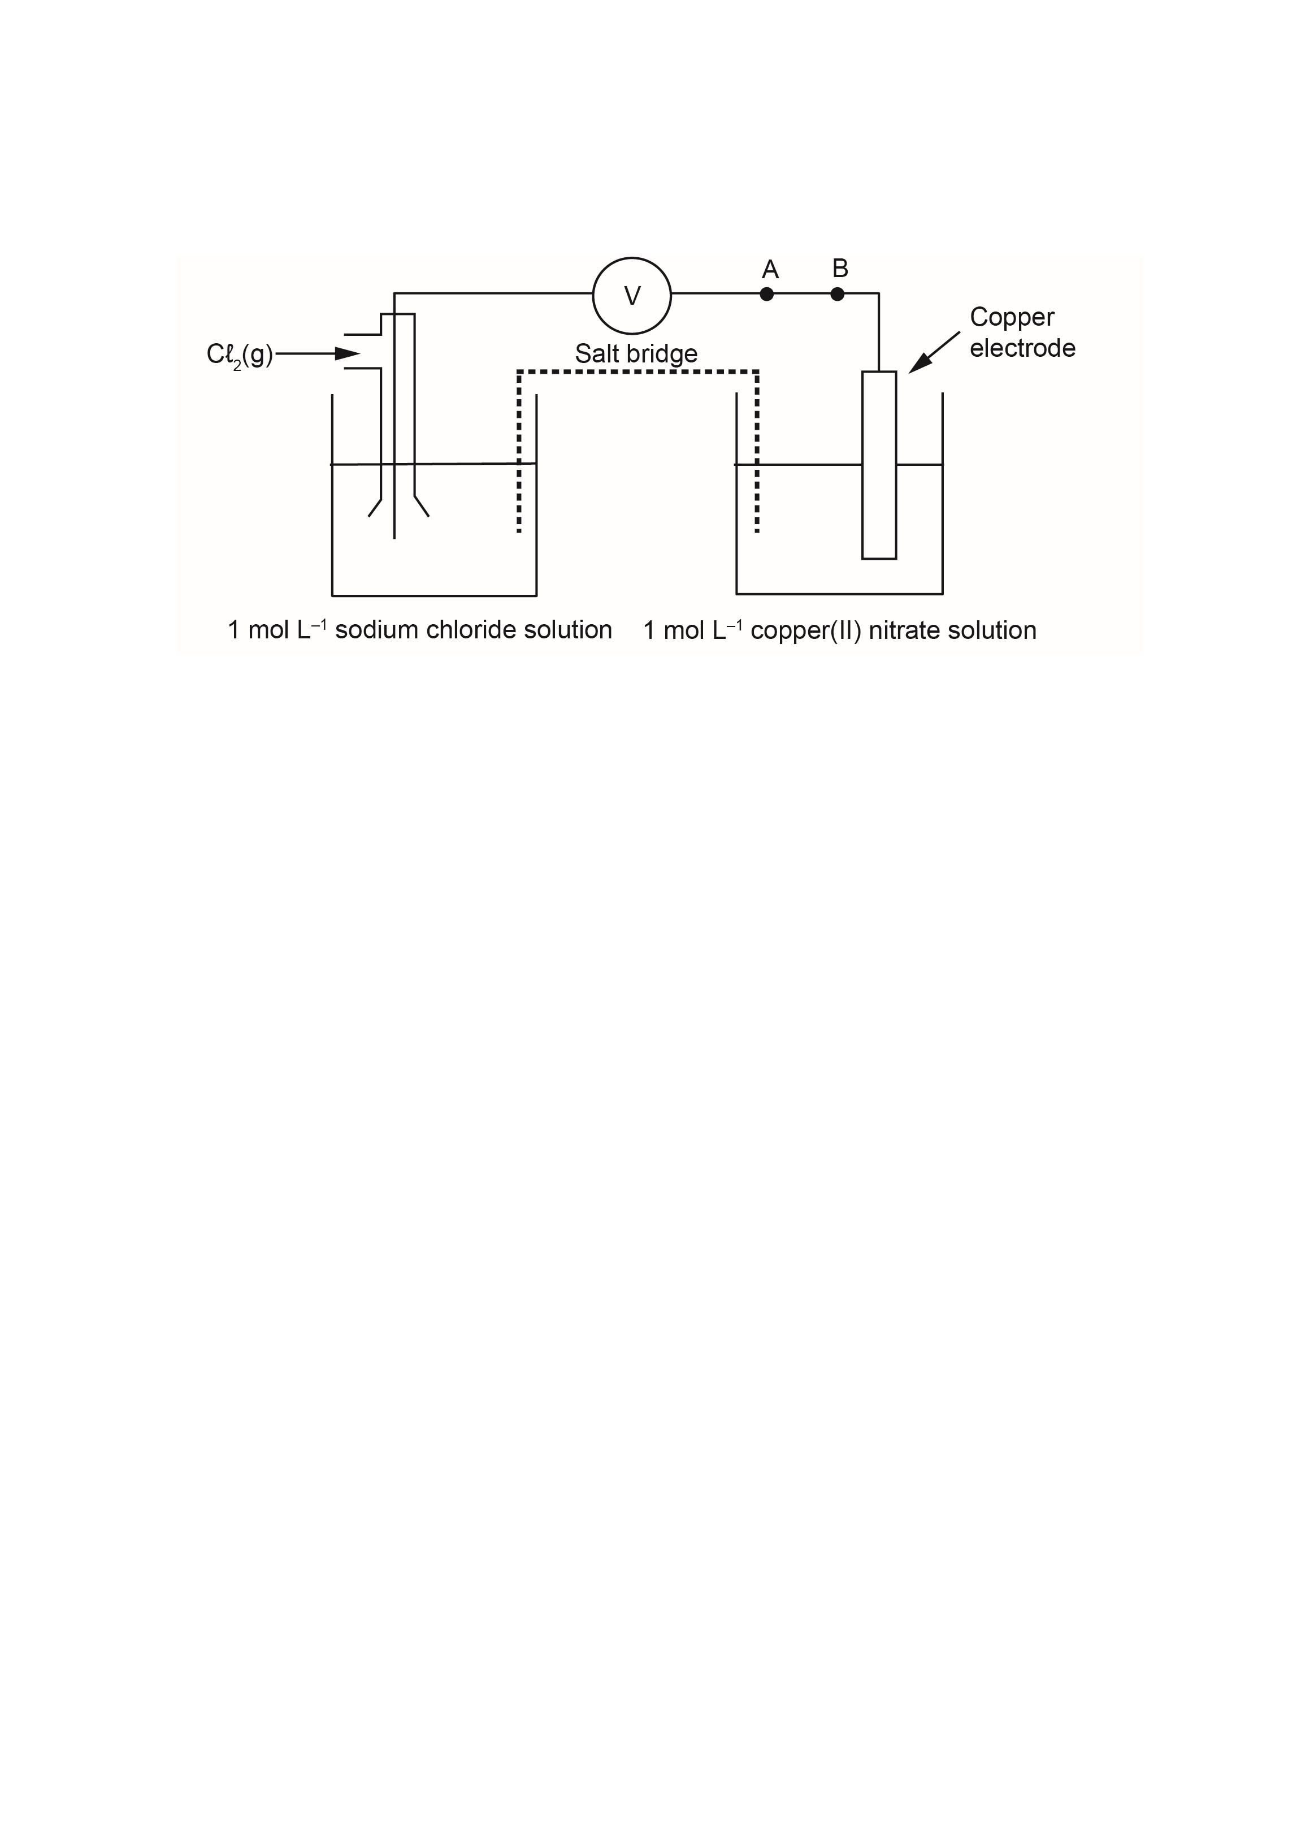

- Draw an arrow between A and B on the diagram to indicate the direction of electron flow. (1 mark)

- Write a balanced equation to represent the overall reaction occurring in this cell. (2 marks)

- State the reason for the reactants being kept in separate half-cells. (1 mark)

- State the observation predicted to occur in the Cℓ₂/NaCℓ half-cell. (1 mark)

- Predict a metal/metal ion cell that could be used in place of the Cu/Cu²⁺ cell to give a higher emf (volts). (1 mark)

WACE 3AB 2014 Q42:
Using the diagram below, explain the role of the following in the operation of a galvanic cell. (8 marks)
- Anode process
- Cathode process
- Lead(II) nitrate electrolyte
- Salt bridge
- Electron flow in external circuit

WACE 3AB 2014 Q36:
A student investigated the effect of concentration of the electrolyte on the electrical potential of electrochemical cells. The student measured the electrical potential for the cell shown in the diagram below. In all trials the volumes of solutions and their temperatures were the same and the surface areas of the copper and zinc electrodes were the same.
The overall cell reaction is as follow:
Zn(s) + Cu²⁺(aq) ⇌ Zn²⁺(aq) + Cu(s)

- What is the independent variable in this investigation? (1 mark)

- What is the dependent variable in this investigation? (1 mark)

- Why did the volumes and temperatures of solutions and surface areas of the electrodes need to be the same in each trial? (1 mark)

The student found that as the concentration of Cu²⁺ ions increased, electrical potential increased, but as concentration of Zn²⁺ ions increased, electrical potential decreased, as shown in the table below.
Trial | Cu²⁺ concentration  (mol L⁻¹) | Zn²⁺ concentration  (mol L⁻¹) | Electrical potential, E  (V)
1 | 0.00001 | 1.00 | 1.01
2 | 0.010 | 1.00 | 1.04
3 | 1.00 | 1.00 | 1.09
4 | 1.00 | 0.010 | 1.16
5 | 1.00 | 0.00001 | 1.26

- Explain the increase in electrical potential as the concentration of Cu²⁺ ions increased and the decrease in electrical potential as the concentration of Zn²⁺ ions increased. (2 marks)

- The student also observed that as the cells were allowed to run for a while their electrical potential slowly decreased from its maximum value. Why did this happen? (2 marks)

The student concluded:
‘As the concentration of the oxidant increases, so does the cell voltage (electrical potential).’
- List two ways to improve the investigation. (2 marks)

One:

Two:
WACE 3AB 2012 Q32:
The vanadium redox battery is an electrochemical cell that is being developed to store electricity produced by solar or wind power on a large scale.
The general structure of the vanadium redox battery is shown below. In this battery, VO²⁺(aq) is converted to VO₂⁺(aq) at one electrode, while V³⁺(aq) is converted to V²⁺(aq) at the other.
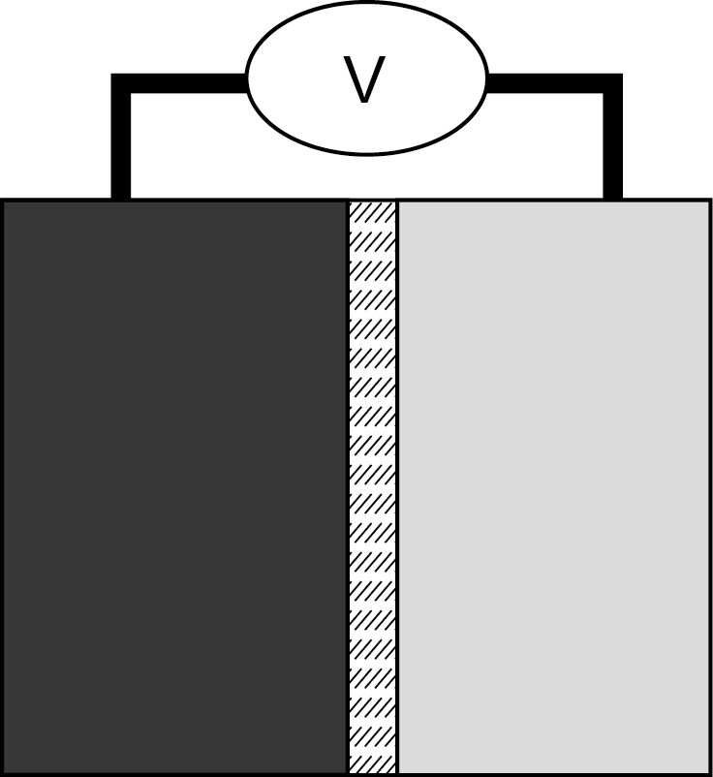
H
2
O(
●
+ VO
)
2+
(
)
aq

→

VO
2
+
aq) + 2 H
(
+
(
aq) + e
–
V
3+
(
aq) + e
–

→

V
2+
(
aq)
Porous membrane
Electrolyte tank
Electrolyte tank

- In the boxes above, identify and label both the anode and cathode. (1 mark)

- Draw an arrow on the diagram to indicate the direction of electron flow. (1 mark)

- State briefly how the porous membrane functions to complete the circuit. (1 mark)

WACE 3AB 2013 Q41:
Lead-acid storage batteries use Pb and PbO₂ electrodes. Pb is the reducing agent, while PbO₂ is the oxidising agent. Sulfuric acid solution is used as the electrolyte.

- The overall battery reaction during discharge is given below. Write and balance the anode and cathode reactions for the lead-acid storage battery. (2 marks)

Anode reaction
Cathode reaction
Overall reaction | Pb(s) + PbO₂(s) + 4 H⁺(aq) + 2 SO₄²⁻(aq) → 2 PbSO₄(s) + 2 H₂O(ℓ)

- Draw a schematic diagram of the lead-acid battery showing the two half-cells. Label the anode, cathode and salt bridge, and indicate the direction of electron flow with an arrow. (4 marks)

- i. With reference to the ‘electrical potential’ of a galvanic cell, describe how the lead-acid storage battery produces current. (2 marks)

ii. What determines the magnitude of the electrical potential of a cell? (1 mark)

WACE 2AB 2013 Q42:

- A quantity of pure chromium chloride (CrCℓ₃) is melted and placed in a heatproof vessel. Two inert electrodes are inserted as shown below and a current flow through the molten liquid. Complete and label the diagram below, showing the:
- Anode
- Cathode
- Direction of electron current
- Ions present and the direction in which they are flowing (5 marks)
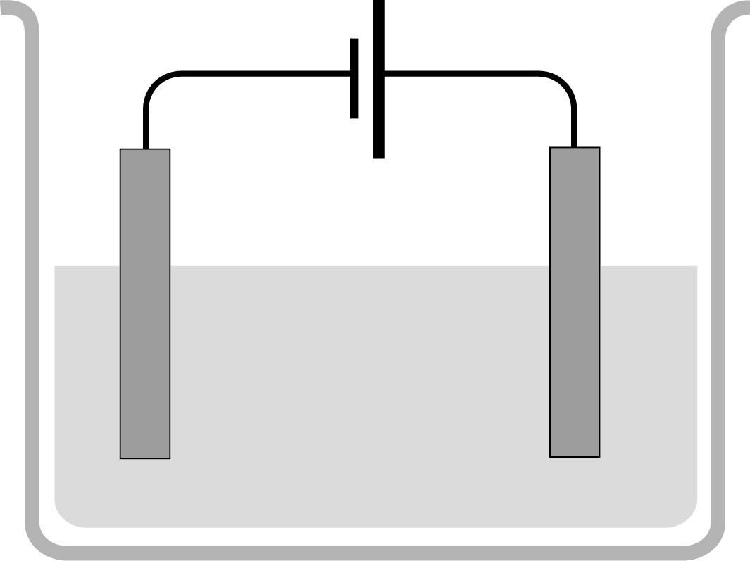
–
+

- Write the oxidation half-equation. (2 marks)

- Write the reduction half-equation. (2 marks)

- Write the overall redox equation. (2 marks)

- Indicate (by circling) which process occurs at the electrode that is connected to the negative terminal. (1 mark)

oxidation reduction redox

- What is acting as the oxidant in this reaction? (1 mark)

- What is produced at the anode? (1 mark)

- State the oxidation number of: (4 marks)

- Cr in solid chromium chloride

- Cℓ in molten chromium chloride

- Cr in chromium metal

- Cℓ in chlorine gas

WACE 2AB 2012 Q41:
A traditional technique for cleaning the tarnish, Ag₂S(s), off silverware without using an abrasive cleaner (which wears away the precious metal) involves setting up a simple electrolytic cell.
The piece of silver to be cleaned can be placed on the bottom of a glass or enamel pan and covered with aluminium foil. A solution of baking soda, NaHCO₃(aq), and table salt, NaCℓ(aq), can be added a brought to boil in the pan. The piece of silver must be in contact with the aluminium foil. The process takes some time but at the end the silverware is sparkling clean.
This process works because tarnish on silver, Ag₂S(s), is caused by sulfide ions. The salt and baking soda solution make an ion-carrying solution that transfer the sulfide ions from the silver to the aluminium foil.

- Write the half-equation where the silver sulfide, Ag₂S(s), is converted to pure silver, Ag(s). (2 marks)

- Write the half-equation where aluminium forms aluminium ions. (2 marks)

- Combine the two reaction half-equations to produce a balanced overall redox equation for the process. (2 marks)

- Explain the purpose of the salt and baking soda solution. (1 mark)

- Circle the substance that is acting as the cathode. (1 mark)

the tarnished silver or the aluminium foil

- Circle the substance at which reduction is occurring. (1 mark)

the tarnished silver or the aluminium foil

- Circle the arrow showing the correct direction in which electrons will flow during this process.
(1 mark)

the tarnished silver the aluminium foil

- State the oxidation number of silver: (2 marks)

- in the Ag₂S tarnish.

- when it has been converted to silver metal:
WACE 2AB 2011 Q33:
In industry, sodium is extracted from molten sodium chloride by electrolysis. Likewise, potassium can be extracted from its molten salts.
- When potassium fluoride is melted, it dissociates to release ions. Write the equation, including appropriate state symbols, to show this process. (2 marks)

- Write the oxidation and reduction half equations for the electrolysis of molten potassium fluoride.
(2 marks)

Oxidation
Reduction

In the extraction of potassium from molten potassium fluoride, an apparatus similar to that shown in the diagram below is used. Refer to the diagram to answer the parts of the question that follow.

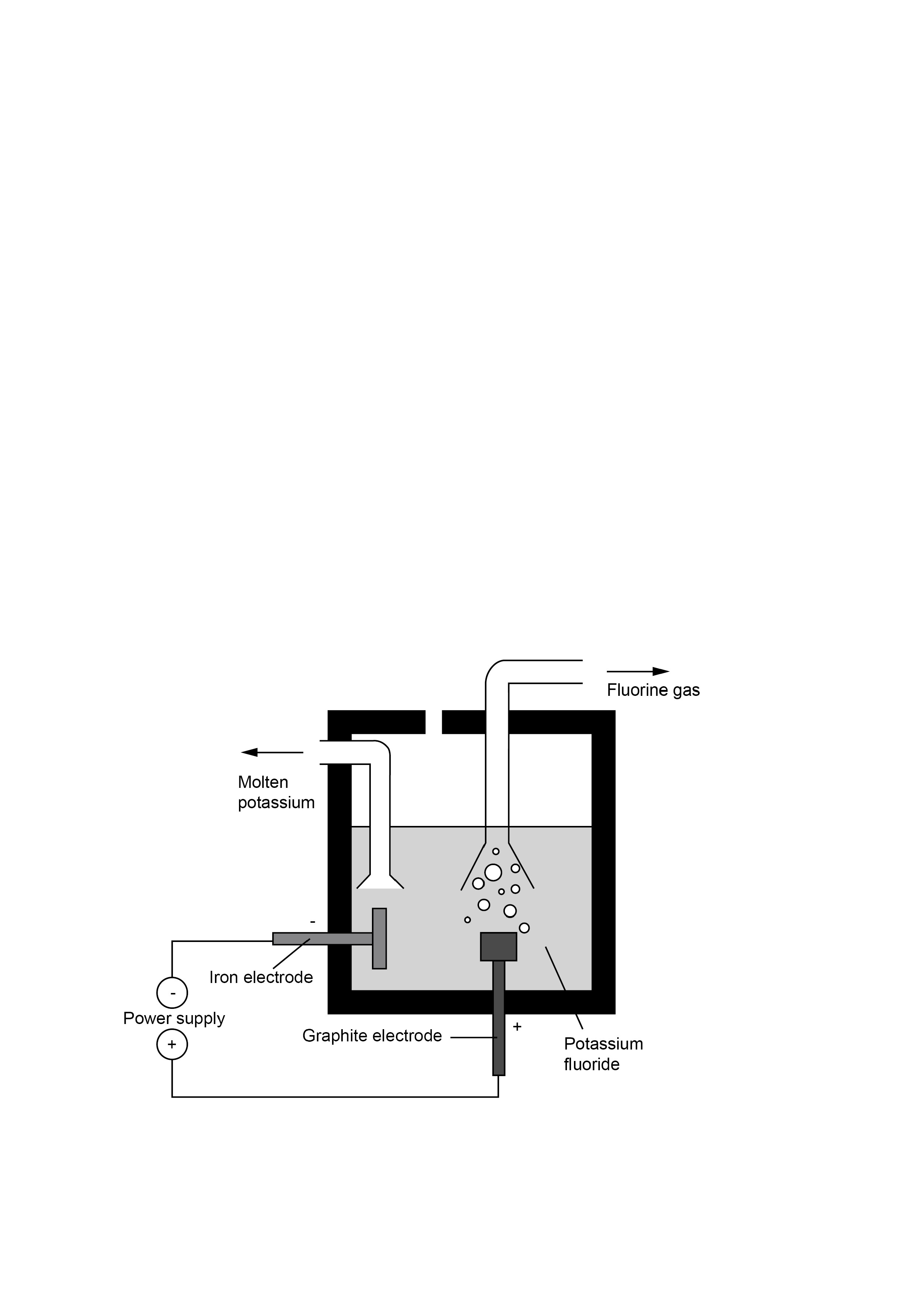

- Complete the table below by writing the electrode (anode or cathode) for which each of the substances shown in used. (2 marks)

Graphite | Iron

- On the diagram, show clearly the direction of flow of fluoride ions. (1 mark)

- Name the substance that forms at the anode. (1 mark)

- Explain why solid potassium fluoride cannot undergo electrolysis. (2 marks)

- List three potential hazards associated with the electrolysis of molten potassium fluoride.
(3 marks)
1
2
3

- State one safety precaution that workers using electrolysis to extract potassium from molten potassium fluoride should take. (1 mark)

WACE 2AB 2010 Q29:
Below is a diagram of the electrolytic cell used to produce aluminium from molten aluminium oxide (Aℓ₂O₃).

Al
2
O
3
(
●

)

+
Power
supply
Direction of
electron flow
Carbon
blocks
Steel
-

The reactions occurring at the electrodes are shown below.
Aℓ³⁺(ℓ) + 3 e⁻ → Aℓ(s)
2 O²⁻(ℓ) + C(s) → CO₂(g) + 4 e⁻

- Complete the diagram by:
- Adding the words anode and cathode to the correct boxes above. (1 mark)

- Showing the direction of the movement of Aℓ³⁺ ions in the cell. (1 mark)

- Combine the two half-equations to give the overall redox reaction for the process occurring.
(2 marks)

- Explain why the Aℓ₂O₃ needs to be in the liquid state. (2 marks)

- An early method of producing aluminium used the reaction of aluminium oxide with sodium metal to produce aluminium metal and sodium oxide.

- Write a balanced equation for this reaction. (2 marks)

- Using the idea of oxidation numbers, explain how sodium is acting as a reducing agent in this process. (3 marks)

WACE 2AB 2014 Q40:
Look at the diagram below, which represents an electrolytic cell that can be used to produce pure copper from a solution of copper(II) sulfate (CuSO₄).
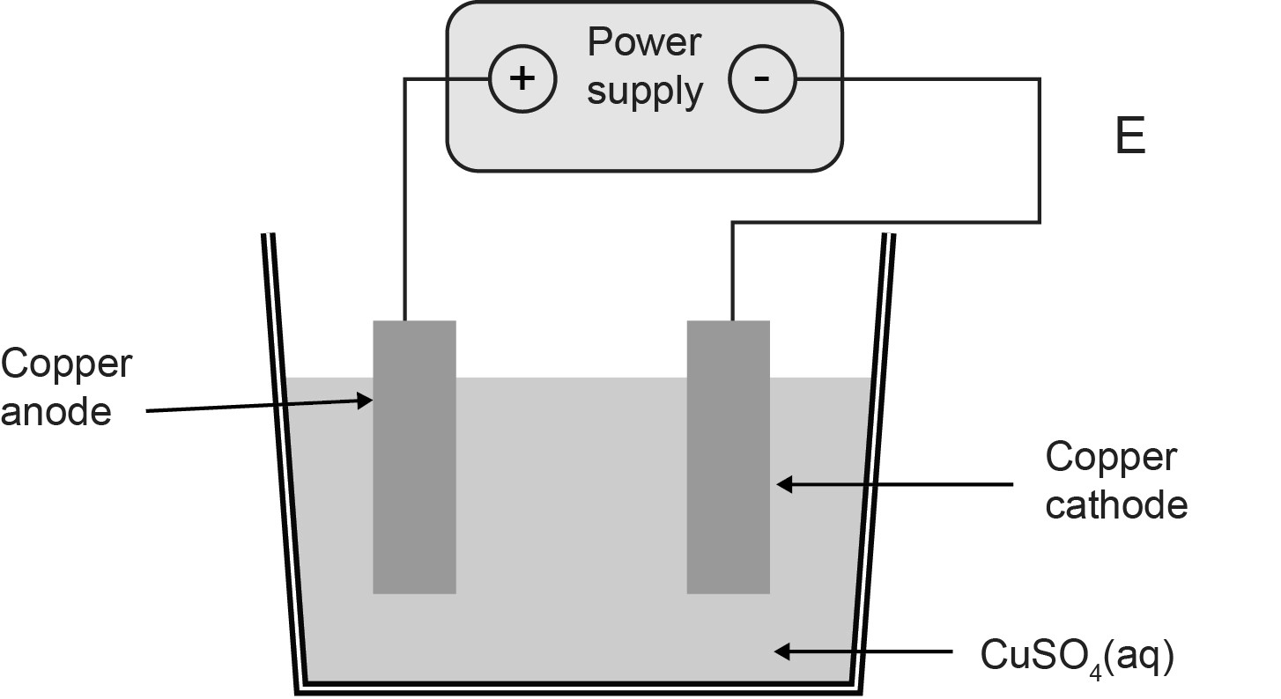

- Draw an arrow on the diagram to show the direction of the movement of electrons in the external circuit at point E. (1 mark)

- Draw an arrow on the diagram to show the direction of the movement of copper ions (Cu²⁺) in solution. (1 mark)

- Why must the power supply be direct current (DC) and not alternating current (AC)? (3 marks)

- Explain why the copper(II) sulfate needs to be dissolved in water for the electrolysis process to work. (3 marks)

WACE 2016 Sample Exam Q41:
You are supplied with strips of three unknown metals, A, B and C, and are required to determine the order in which they are reduced, from most easily to least easily.
Using a voltmeter, electrical leads and clips, standard laboratory glassware and the typical range of chemical found in most laboratories, design an investigation and describe the procedures to be followed to determine the order of reduction for the metals. Use a labelled diagram to support your description. Ensure that you explain the purposes of substances or equipment (excluding beakers or other glassware) used.
Indicate the data you will collect and explain how this data gives the order of reduction. (10 marks)

